TECHNICAL PROJECT REPORT

Automatic Sunlight-Based Roof Control System for BSF Cultivation
  - Development, testing, and reliability assessment

COMPLETION STATUS
The system is fully integrated and tested; automatic roof movement and safety controls operate as intended.

Executive Summary
This project automates a sliding roof above a Black Soldier Fly (BSF) cultivation area to regulate sunlight exposure, protect the larvae from excessive heat, and reduce manual work. The system combines an Arduino Uno, BH1750 illuminance sensor, two relay channels, a 230 V AC geared motor, and open/closed limit switches. Outdoor comparison with a reference lux meter confirmed consistent sensor response. Following circuit correction, endpoint integration, bracket improvement, and control-code modification, the complete roof mechanism was tested successfully. It now opens and closes automatically according to sunlight conditions, stops accurately at both endpoints, and uses a motor run-time fail-safe to prevent continuous operation if an endpoint signal is missed.

1. Project Need and Objectives
BSF cultivation requires stable environmental conditions. Excessive sunlight can increase heat exposure within the cultivation area, while fully manual roof operation requires continuous attention. The project was therefore designed to:
- measure ambient light and command roof opening or closing;
- stop travel at the fully open and fully closed positions; and
- move the existing 50 kg roof reliably while reducing manual intervention.
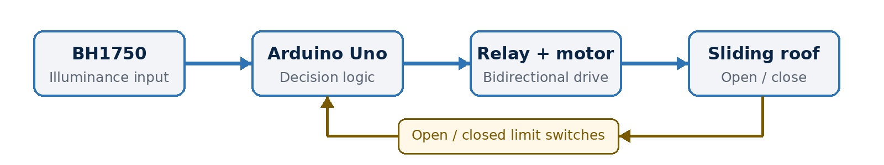
Figure 1. Control architecture of the automatic sunlight-based roof system.

2. System Design and Operating Principle
The Arduino Uno acts as the main controller. The BH1750 measures ambient light and sends the illuminance value to the controller through I2C communication. Two relay channels control the geared motor in the opening and closing directions, while two limit switches identify the fully open and fully closed roof positions.
During operation, the controller compares the light level with the programmed decision range and activates the appropriate relay. The motor moves the roof until the corresponding limit switch is reached, after which it stops immediately. The program prevents simultaneous activation of both directions, while a maximum motor run-time limit provides a secondary stop if the endpoint signal is unavailable.
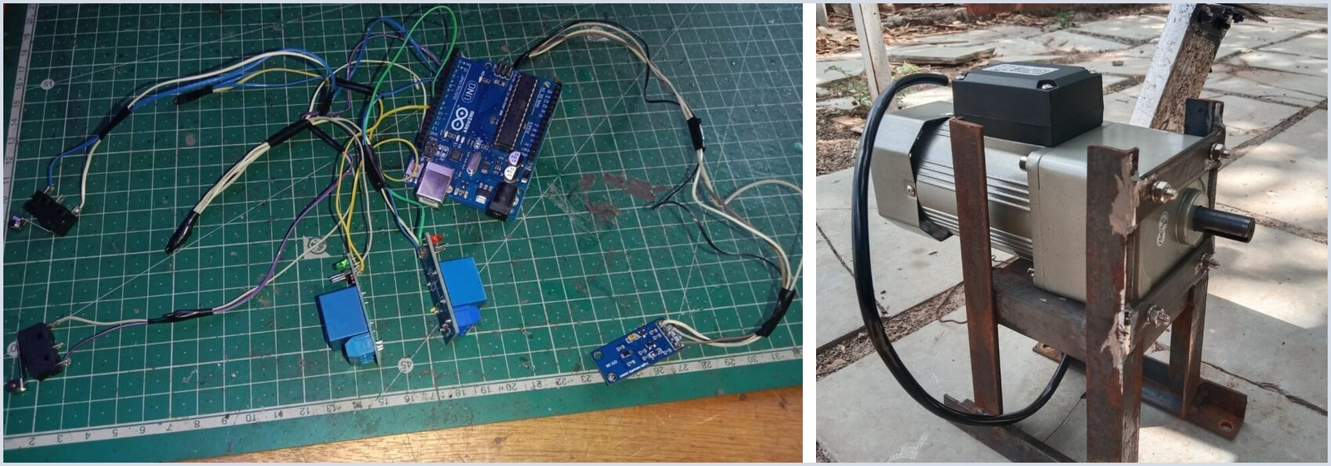
Figure 2. Bench controller assembly (left) and selected AC geared motor on its welded frame (right).

3. Mechanical Sizing and Drive Selection
The existing roof moved smoothly by hand, but the original motor could not overcome the load. The documented sizing inputs and independently checked results are summarized below.
DESIGN ITEM | VALUE / RESULT
Roof / motion | 50 kg; horizontal sliding on low-friction bearings
Travel target | 2.44 m in 30 s = 0.0813 m/s
Pulley | 43 mm radius; approximately 18.1 rpm at target speed
Friction estimate | mu = 0.04; F = 19.62 N
Pulley torque | 0.844 N m ideal; 2.53 N m with one safety factor of 3
Converted torque | Approximately 25.8 kgf cm with one safety factor of 3
Selected drive | 90 W, 230 V AC geared motor with sufficient operating reserve
Table 1. Motor-sizing inputs and verified design results.
MOTOR SELECTION RESULT The design torque is approximately 2.53 N m, or 25.8 kgf cm, after applying a safety factor of 3. The selected geared motor provides additional reserve for starting load, transmission losses, alignment, and wear. Testing confirmed smooth movement through the complete roof travel.

4. Development and Test Results
ACTIVITY | RESULT / STATUS
Planning and roof inspection | Requirements defined; original motor found under-torqued.
Component and integration tests | Relays, limit switches, and the BH1750 were verified before complete assembly.
Circuit correction | Electrical issues were resolved and stable automatic operation was restored.
Endpoint integration | Both limit switches were positioned on a custom bracket for accurate roof stopping.
Final improvements and verification | The bracket and control code were improved; complete testing confirmed reliable operation and fail-safe stopping.
Table 2. Development sequence from initial planning to final system verification.
Final testing confirmed that the light sensor, controller, relay outputs, geared motor, limit switches, and mechanical roof operate together correctly. The roof completed opening and closing cycles smoothly, stopped at the intended endpoints, and remained protected by the motor run-time limit if normal endpoint detection was unavailable.

5. Final System Performance
- Automatic response. The BH1750 continuously measures ambient light, and the Arduino selects the required roof position according to the programmed sunlight range.
- Smooth roof movement. The geared motor provides sufficient torque to move the 50 kg sliding roof through its full travel without manual assistance.
- Accurate endpoint stopping. The open and closed limit switches stop the motor at the correct positions, preventing mechanical over-travel.
- Fail-safe protection. If the expected limit-switch signal is not detected, the maximum run-time control switches the motor off and prevents continuous operation.

Conclusion
The automatic sunlight-based roof control system was completed, integrated, and tested successfully. All major components work together as intended: the sensor detects changing light conditions, the Arduino controls the roof direction, the geared motor moves the roof smoothly, the limit switches stop it accurately, and the run-time fail-safe prevents continuous motor operation. The system therefore meets its objective of regulating sunlight exposure automatically while reducing manual intervention and improving operational safety for the BSF cultivation facility.

