FINAL PROJECT REPORT

Automation of Solar Still
  - Design, development and testing of an automatic solar tracking mechanism
Prepared by: Dharmesh Makvana
Organization: Design Innovation Center, Vigyan Ashram, Pabal
Development period: June–September 2026

Project overview
This project developed an automatic solar tracking mechanism for the parabolic trough concentrator associated with a solar still. The work combined improvements to the rotating support, development of a belt winding transmission, stepper motor selection, and implementation of an ESP32-based solar position algorithm. The purpose was to adjust the concentrator orientation as the Sun moves, reducing the need for repeated manual positioning and supporting consistent solar energy collection.
The objectives were to reduce rotational friction, achieve controlled movement in both directions, improve belt engagement, and integrate the mechanical drive with automatic tracking control. Initial integrated trials confirmed that the assembled system responded to the calculated tracking commands.

Working principle
The parabolic trough reflector concentrates sunlight along a focal line at the receiver. The collected heat is transferred to water in the solar still, where evaporation takes place. Water vapour condenses on the cooler transparent cover, and the condensate flows into a collection channel. Tracking adjusts the concentrator about its rotation axis to maintain the required orientation as the solar position changes. Improved alignment is intended to support heat collection and evaporation; the work reported here focuses on development and functional testing of the tracking mechanism.
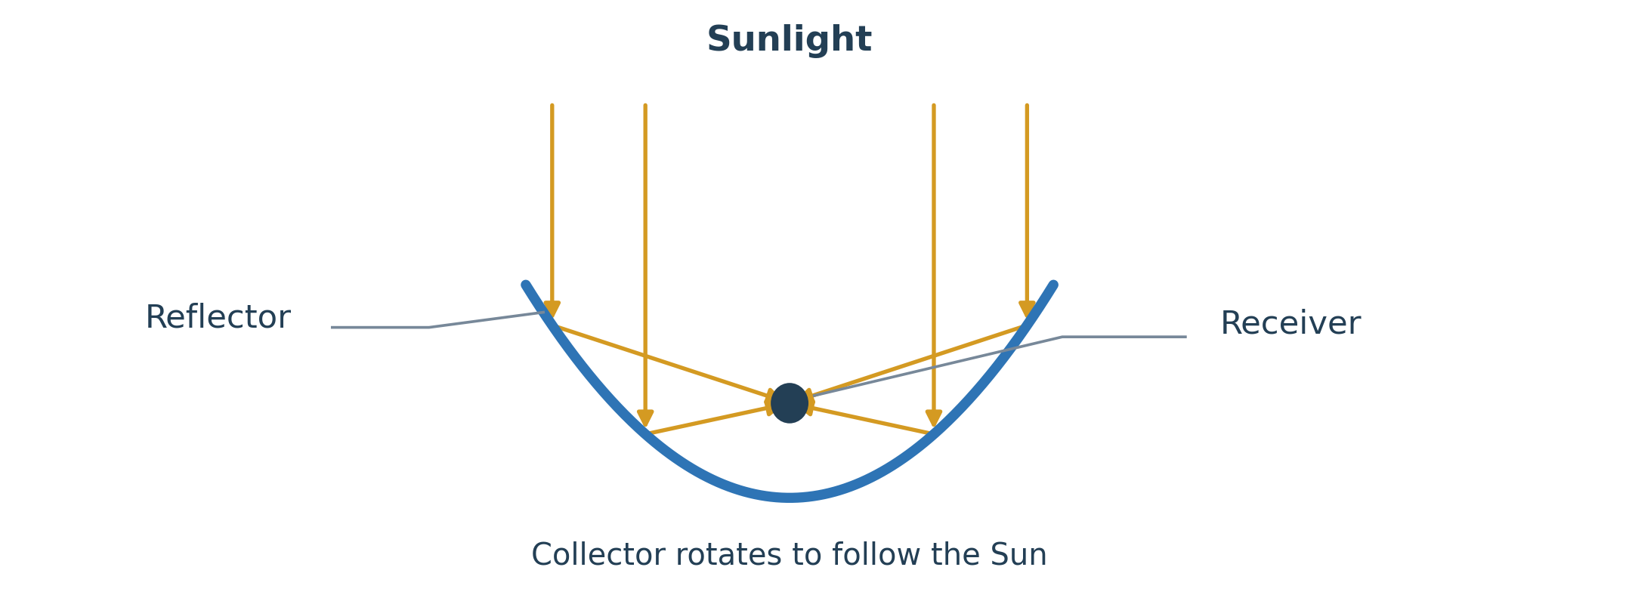
Figure 1. Solar concentration principle (simplified cross-section; not to scale).

Structural modification
The existing assembly was dismantled and inspected before automation. Excessive friction in the original rotating support restricted smooth movement. The support was redesigned using pillow block bearings, welded mounting bolts and a steel pipe serving as the rotation shaft. The shaft and bearings were secured to the supporting frame, improving alignment and reducing resistance to rotation.
The stepper motor was mounted at the base of the frame, with a belt connecting the drive to the collector. The balanced collector arrangement reduces the gravitational load on the drive, allowing the motor to primarily overcome rotational resistance and transmission losses.
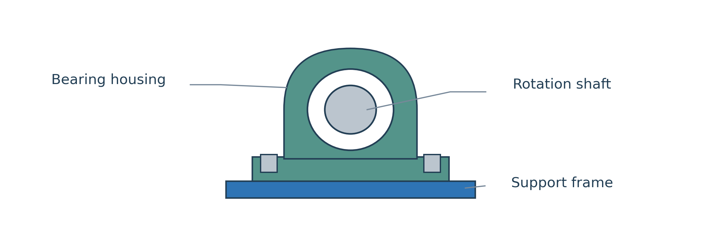
Figure 2. Bearing support for the rotation shaft (simplified front view).

Torque calculation and motor selection
A load test used a 2 kg mass at a distance of 1.1 m from the rotation axis. The load was sufficient to rotate the collector. The following sizing calculation uses a nominal perpendicular test load, a 25 mm drum radius and a 45° belt angle relative to the collector lever arm.
Quantity | Calculation | Result
Applied force, F | 2 × 9.81 | 19.62 N
Applied test moment, τ | 19.62 × 1.1 | 21.58 N·m
Equivalent belt pull, T | 21.58 / (1.1 × sin 45°) | 27.75 N
Nominal motor torque | 27.75 × 0.025 | 0.694 N·m
Design torque, factor of 3 | 0.694 × 3 | 2.08 N·m  ≈ 21.24 kgf·cm
These values form a nominal sizing estimate. The load test establishes a sufficient applied moment, while the operating demand depends on belt geometry, winding radius, friction and external loading.
A NEMA 23 stepper motor was selected for the drive and integrated with the ESP32 through a stepper motor driver. The design used a factor of three to provide an allowance for transmission losses, starting and stopping, belt elasticity and operating disturbances.

Development of the belt transmission
Early transmission trials showed that belt tension changed as the collector rotated. Slack reduced contact with the winding drum and caused slipping or partial disengagement. Idler pulleys and spring tensioning were explored, but later testing showed that slack could still occur at some positions.
Rope and plastic rope were also tested with multiple turns around a smooth drum. Friction was insufficient for dependable motion transfer. These trials led to a revised arrangement with two pulleys: one winds the belt while the other releases it, and the roles reverse when the motor changes direction.
The revised drive initially suffered from overlapping belt paths and insufficient clearance inside the casing. The casing was redesigned with more space around the winding drum, and a separating plate was added to keep the winding and unwinding paths apart. After assembly, testing showed substantially reduced slack and smoother collector movement in both directions.
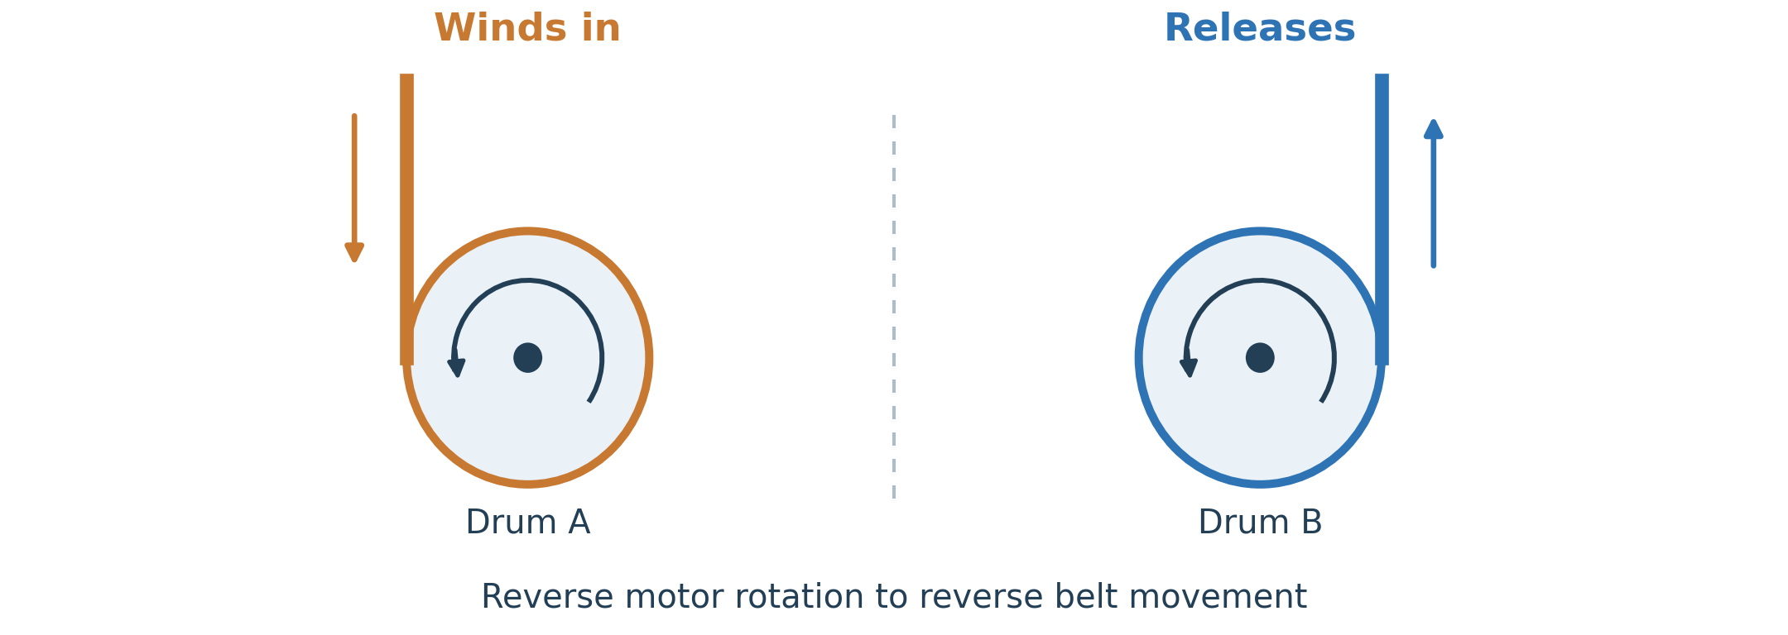
Figure 3. Paired winding action (schematic end views; not the physical drum layout).

Control system and automatic operation
The control system consists of the ESP32 microcontroller, stepper motor driver, NEMA 23 stepper motor and the modified belt transmission. The tracking algorithm uses date, time, latitude and longitude to calculate the solar position and determine the required collector orientation. The controller then commands the motor to move the collector to the corresponding position.
As the calculated position changes during the day, the motor winds one side of the belt while releasing the other. This action rotates the collector about its supported shaft. The mechanical modifications and control code were brought together for initial integrated testing during 1–7 September 2026.
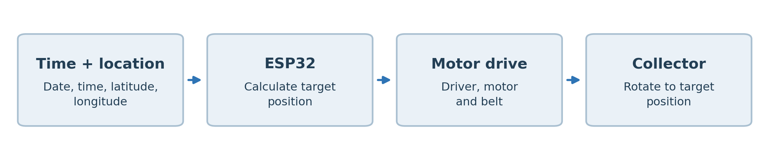
Figure 4. Automatic tracking control sequence.

Testing and results
Testing progressed from checking the rotating structure and motor response to operating the complete tracking assembly. The principal observations from the final configuration are summarized below.
Item checked | Observed result
Rotating support | Smooth movement after the bearing and shaft modification.
Belt and casing | Improved belt engagement with only minimal slack observed.
Bidirectional movement | Collector rotated in both directions in response to motor commands.
Integrated tracking control | Controller, driver, motor and mechanism operated together successfully in initial trials.

Tracking accuracy
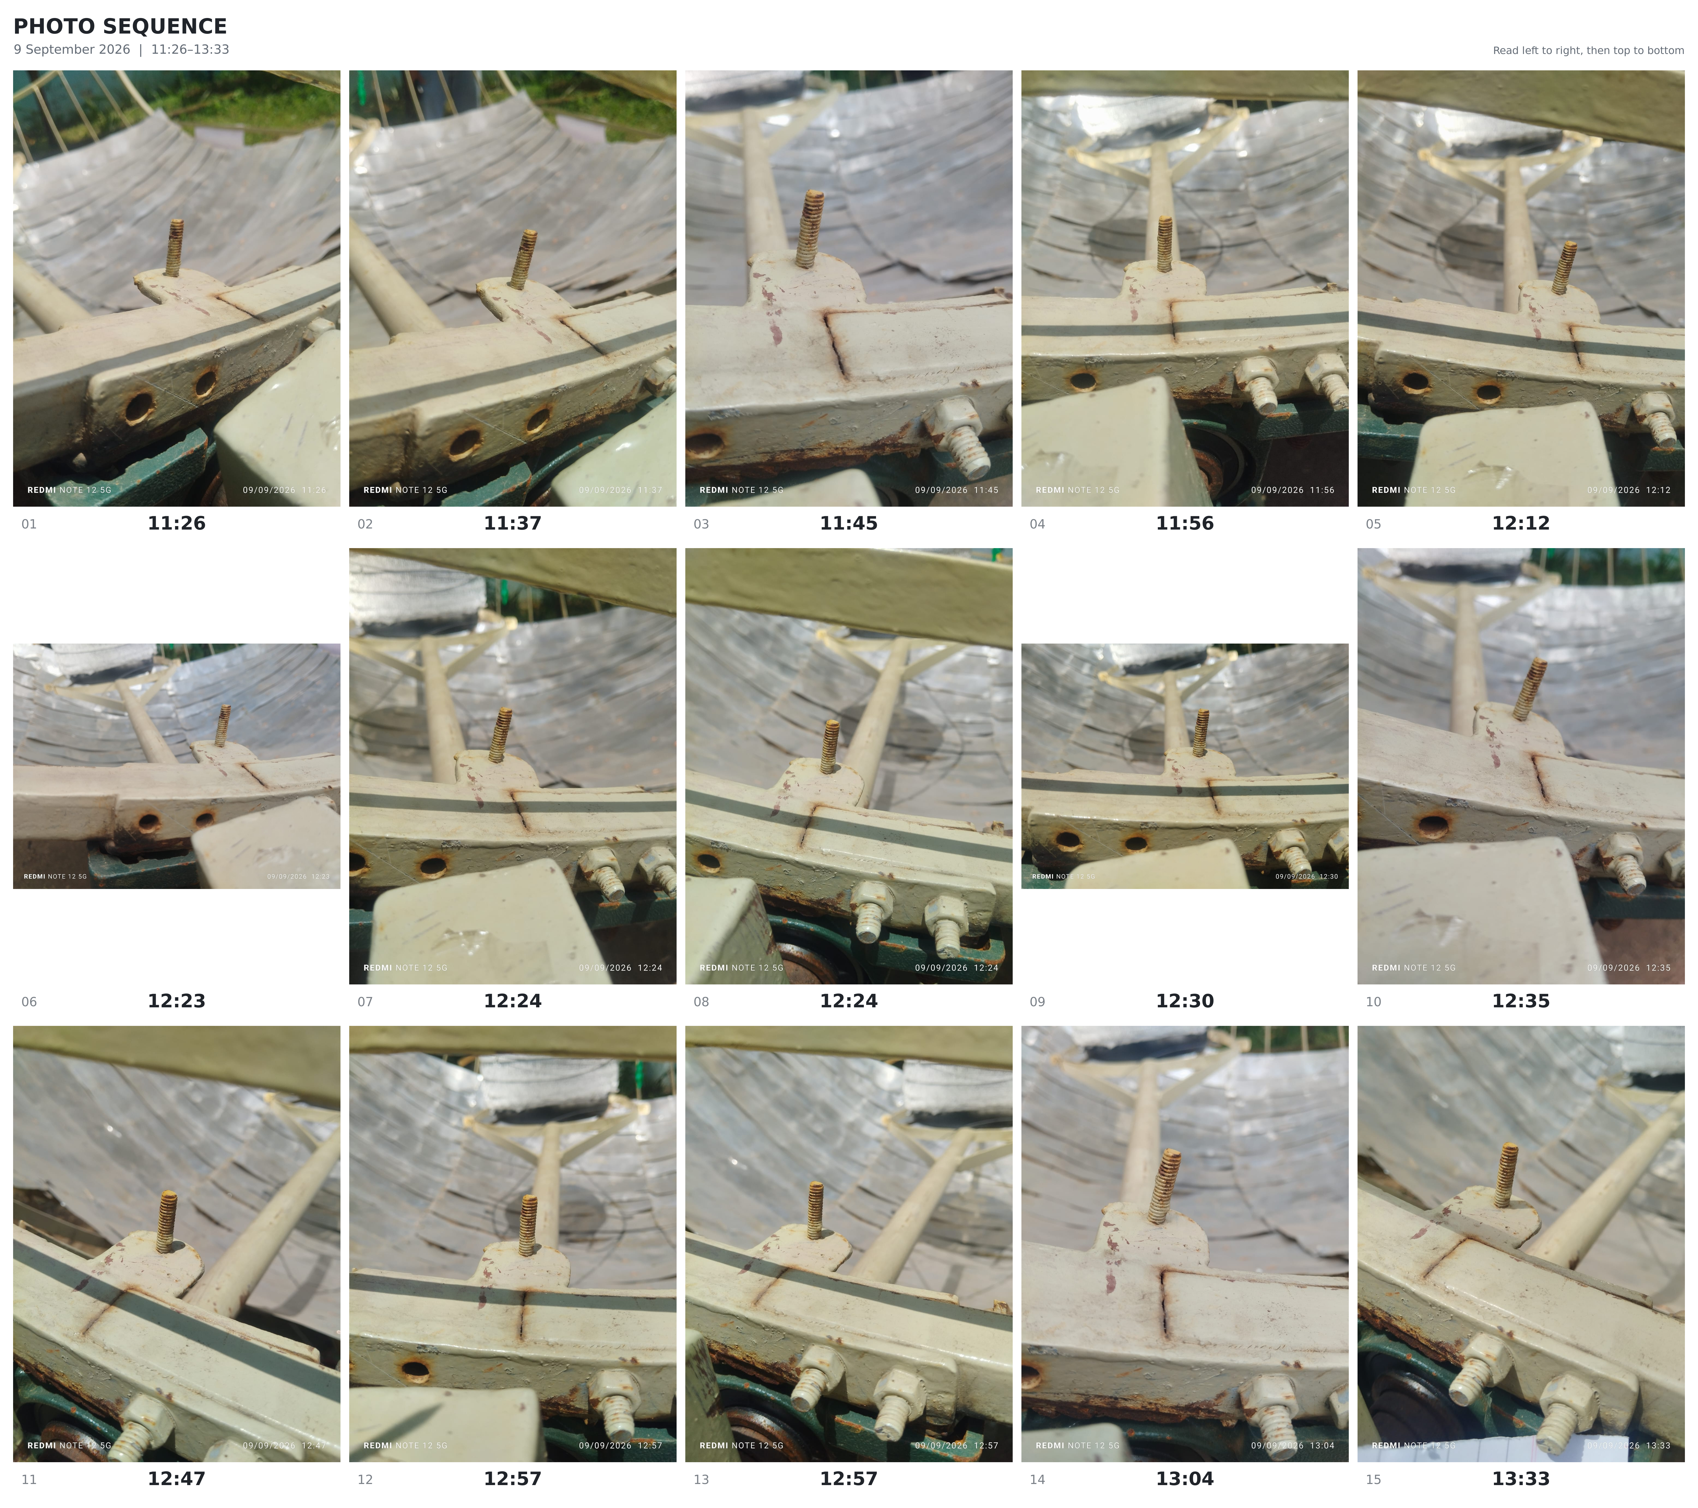
Figure 5. Chronological Photo Sequence for Evaluation of Single-Axis Solar Tracking Performance

The single-axis east–west tracking system was tested, during which the stud shadow remained close to the reference point while the dish continuously followed the Sun. Based on photographic observation, the controlled-axis tracking error is estimated to be within approximately ±2–3°. This is an approximate field estimate, as the dish was installed on a slightly inclined surface and the north–south solar movement is not controlled by the single-axis mechanism.

Conclusion
The automation mechanism for the solar still concentrator has been developed, assembled and functionally tested. The redesigned bearing support, two-pulley winding arrangement, enlarged casing and separating plate improved the transmission, while the ESP32 tracking algorithm enabled automatic position commands. The integrated system operated as intended during testing. The project has achieved its functional automation objective.

