- ORGANIZATION DETAILS

  - Organization profile

Organization Name: Vigyan Ashram
Address: A Centre of Indian institute of education
At/Po – Pabal, Tal -Shirur, Dist.-Pune. 412 403
Mobile No. 0213829236
Email ID: vapabal@gmail.com
Website: http:\\www.vigyanashram.com
Founder: Dr. S. S. Kalbag.
Director: Dr. Yogesh Kulkarni

1.2 Organization background
Vigyan ashram is Centre of Indian Institute of Education. Vigyan ashram is located in village Pabal approximately 70 km from Pune on Rajgurunagar-Shirur road. A scientist turned education list late Dr. S. S. Kalbag started Vigyan Ashram in 1983 to find out a solution to the problem in education ‘’Vigyan’’ means a search of truth and ashram symbolizes simple living and high thinking, it is a modern version of the old Gurukul system. Over the year Vigyan ashram developed a complete program for giving training to the youth in rural and urban areas.
Vigyan ashram developed several innovations and technologies and successfully commercialized them by training school drop outs. Many governments and private organization and individual donor supported program of the ashram.
Vigyan ashram believes in philosophy of learning while doing. It is the same way by which we learn to speak out mother tongue. This natural system of learning teaches us without overburdening us by teaching learning process. It believes activity to hand is the quickest way to developed intellect. And also believes various rural development tasks can be integrated with school education.

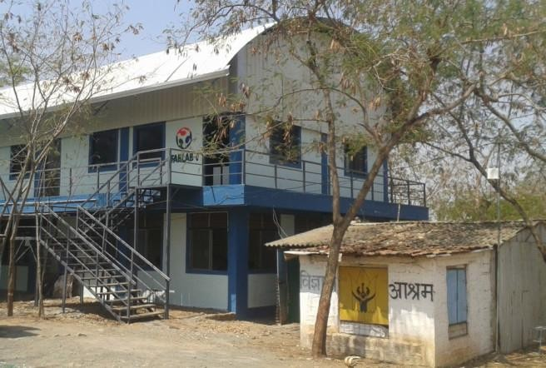
Fig. 1.1 Vigyan ashram pabal

1.3 Training programs
Vigyan ashram conducts different training programmes throughout the year the different training programmers are user level courses, technician level courses, management level courses, academic level courses, awareness courses (through multimedia system) and technology transfer camps (off campus).
1.4 Diploma in basic rural technology ( DBRT program)
DBRT is one year residential diploma courses offered at Vigyan Ashram. This course is recognized by the National Institute of open schooling and useful for students interested to learn by hands this is a multi-skill program in which training is given in the area of works in each of the section for 3 months they will work along with instructors to give various services. Most of the campus of Vigyan ashram is built by our own students as part of their project work.
    - Engineering: (Fabrication & Construction & Basic Carpentry, Engineering, Drawing & Costing)
    - Energy & Environment: (Electrical, Motor Rewinding, survey techniques, Solar/Biogas etc.)
    - Home and Health: (Sewing, Food Processing and Rural lab)
    - Agriculture & Animal Husbandry: (playhouse, poultry, goat farming, dairy nursery techniques)
Beside this computer, meditation, sports, adventure, etc. are part of the program Student.

1.5 Fab lab
Centre of Bits and Atoms of Massachusetts Institute of Technology (MIT), USA installed a FAB LAB at Vigyan ashram. FAB LAB is a collection of set of computer operated fabrication tool which empowers to do lots of things. Rural areas are having lots of problems. Each problem is an opportunity to get some solution, but it is true that many of the scientific institution and big R & D Lab might not be interested in finding solution to the small problems Reason is very simple, the potential volume of such solution will be limited.
Equipment of FAB LAB at Vigyan Ashram. Following equipment are installed at Vigyan Ashram
- Laser Cutting Machine.
- Scroll Saw.
- Computers (models software).
- LCD Projector, Printer, Digital Camera.
- Electronic table (soldering equipment, etc.)
Vigyan Ashram encourages invention and innovation and put them to use. They also try to develop technology for income generation. Many of the technologies are developed by their students, who are dropouts from the to present education system.
- Vigyan Ashram Developed Following Technology:
- Pabal Geodesic Dome
- Mechanical Bull Tractor and agricultural equipment’s
- LED Lighting solutions for rural areas
- Biogas Based Electrical generation

1.6 Objective of organization
Following are the objective of organization:
    - To learn while doing.
    - To provide same quality of education to all.
    - To use modern technology to improve quality of education.
    - Every Village will have the equipment and the skills that are the basis of all modern industry. To achieve the inventions at very low cost.
    - To access the majority of the rural section with most modern techniques and this will split development from the grass-roots and ultimately, propel India intothenewag

II.MODIFICATION OF PULVERIZER HOPPER FOR BROWN MATTER
2.1 Introduction:
Compost is decomposed organic material, such as leaves, grass clippings, and kitchen waste. It provides many essential nutrients for plant growth and therefore is often used as fertilizer. Compost also improves soil structure so that soil can easily hold the correct amount of moisture, nutrients and air.
Composting also has “upstream” benefits, which further conserve our resources and reduce greenhouse gas emissions. When this compost is used on fields, it displaces synthetic chemical fertilizers. Fertilizer production requires intensive fossil fuel energy and seriously impacts human and environmental health.
Fall leaves become even more valuable when you shred them. That's because, left whole, leaves can create dense, slimy mats that block air and water, suffocating the plants and soil underneath them. Plus, whole leaves take their time decomposing in the compost pile. Using a leaf shredder solves these problems and opens more possibilities for making the most of your leaves.
As a source of nutrients in perennial gardens: The longer leaves sit on the lawn, the more nutrients they lose through leaching. By raking leaves as soon as they fall and then shredding and spreading them in perennial beds, all those nutrients will enter the soil right where plants need them.
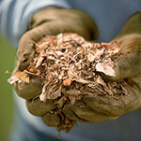
Fig 2.1.Shredded leafs
As a winter mulch for perennials, roses and shrubs: Shredded leaves create a fluffy mulch that protects plants against extreme cold and insulates them from fluctuating winter temperatures that can cause plants to break dormancy too early. Shredded leaves are an ideal insulating mulch to use with Row Crop Protector. In the vegetable garden: In late fall, cover cool-season vegetables with a thick blanket of shredded leaves to insulate them, prolonging the harvest into winter. Layer shredded leaves over empty beds to deter winter weeds and help prevent the soil from compacting during heavy rains.
To improve soil drainage and water-holding capacity: As they decompose, shredded leaves build soil humus, which helps loosen heavy clay soil and improves the water-holding capacity of sandy soil. In the compost pile: Shredding dramatically increases the surface area of the leaves, so they decompose much faster. Rich in carbon, fall leaves are perfect for layering with nitrogen-rich grass clippings and kitchen scraps.
Leaves are packed with trace minerals that trees draw up from deep in the soil. When added to your garden, leaves feed earthworms and beneficial microbes. They lighten heavy soils and help sandy soils retain moisture. They make an attractive mulch in the flower garden. They're a fabulous source of carbon to balance the nitrogen in your compost pile. And they insulate tender plants from cold.

  - Using Shredded Leaves
If you have an abundant source of leaves in the fall, shred them. Your garden will benefit in a big way. Here how to use them:
- Insulate Tender Plants: A 6-inch blanket of leaves protects tender plants from winter wind and cold. Cover cold-hardy vegetables such as carrots, leeks and beets and we’ll be able to harvest them all winter.
- Boost Your Compost Pile: Carbon-rich leaves balance high-nitrogen compost ingredients such as fresh grass clippings.
- Improve Your Soil: Mix shredded leaves right into your garden. Next spring, your soil will be teeming with earthworms and other beneficial organisms.

  - The Benefits of Leaf Compost
Composting leave smales a dark, rich, earthy organic matter that can be used like soil. It adds nutrients to garden soil and the larger particle size helps enhance the tilth and loosen compacted earth. Compost retains moisture and repels weeds when used as to dressing or mulch.
2.3 Need of brawn matter:
The climate and seasons changes will have a big effect on composting. Small adjustments can be made when changes happen such as when the rainy season approaches.
  - Moisture Content:
Microorganisms living in a compost pile need enough moisture to survive. Water is the key element that helps transports substances within the compost pile and makes the nutrients in organic material accessible to the microbes. Organic material contains some moisture in varying amounts, but moisture also might come in the form of rainfall or intentional watering.
2.5 Problem occures due to high moisture and solution:
Compost piles smell like ammonia when they give off excess nitrogen (N) in the form of ammonia (NH3). This problem occurs most often if a composter has been adding high-nitrogen products. The smell signals that the pile has a surplus of nitrogen from too many green materials. The short-term solution is to turn the pile or even spread it out to allow the excess ammonia to vaporize.
Mixing in brown material can also restore the carbon-nitrogen balance. The long-term lesson is restoring the carbon-nitrogen balance. Increase carbon or brown materials, by adding straw, sawdust, peanut shells, or shredded, unbleached or colored cardboard to the pile. Mix them in well. In the futures, add less nitrogen.
Dead leaves compost slowly under any conditions because they’re so high in carbon. If they’re not mixed with other ingredients, they’ll compress into a nearly oxygen-free lump. In both cases, it’s best to turn the pile, mixing these ingredients in with others. When adding new materials, don’t leave them in a clump but mix them in throughout the pile, Shred them.
for shredding this brawn material ,we used pulverizer which was already designed for grains.
2.6 Objective:
- To convey the brawn material from hopper of pulverizer to achieve the exact efficiency of machine.
- Study of Shredder machine with Different elements like Blades, chain and sprocket Drive, Single-Shaft conveying mechanism.
- Fabrication of conveying system in small Size
- Less manufacturing cost with best output

2.7 Project Scope:
This project is limited to the scope as follows;
- Research, Design and Fabrication of feeding Machine

2.8 Multipurpose pulverizer :

Fig 2.2 pulverizer

2.8.1 Machine specification:
Table No. 2.1
Sr. No. | Specification
1 | Features | SSH1
2 | grinding capacity | 25-30 kg/hr.
3 | power consumption | 1.4 kwhr.(unit)
4 | electric motor | 2HP single phase
5 | weight | 30 kg
6 | dimensions | 25"×16"×44"

Pulverization: A solid substance in the form of tiny particles
Pulverizer: A pulverizer grinder is a mechanical device for the grinding of many different types of material.
For example, a pulverizer mill is used to pulverize coal for combustion in steam generating furnance of fossil fuel power plants.

II.SCHEDULE OF WORK
Sr. No. | Date | Schedule of work
 | 01.01.2019 | - Reporting to Vigyan Ashram.  - Introduction of Vigyan Ashram
 | 02.01.2019 to 15.01.2019 | - Completed assignment 1st table plywood fix for incinerator.  - Completed assignment 2nd making cloth hangers.  - Completed assignment 3rd making of hand operated shredder for composting.  - Learning of plasma cutting machine, laser cutter, and 3D printer, Basic information about Google sketch up software.  - Fixed project entitled modification of pulverizer hopper for dry matter.  - Attended lectures - Belongingness, Design and Problem definition.
 | 16.01.2019 to  31.01.2019 | - Designed the model of Polyhouse on Google sketch up.  - Learning of 123D design software  - Completed 4th assignment - made powder of dry matter  - Tested the designed waste chopper.  - Made a stand for a water tank in Pabal Village.  - Studied literature for shredding and conveying calculations.  - Found out bulk density of dry leaves.  - Attended Lecture - Temperature, Specific heat, Latent heat, Humidity, Relative humidity
 | 01.02.2019 to 15.02.2019 | - Learning of Solidworks software.  - Took test on the existing shredder prototype with reducing number of blades.  - Studied the different conveying systems.  - Selected some designs of blades, and initially draw in notebook. collected information about these blades which was used for cutting cum conveying system.  - Ideation of system.  - Fixed the dimensions of blade on the basis of hopper dimensions as a prototyping.  - Designed blades in solid work.  - Helped to level ground in dome for azolla.  - Attended lectures - Voice of Customer
 | 16.02.2019 to 28.02.2019 | - Finalized the designs of gears, clearance plate, and side plate.  - Found out material for shaft.  - Blades, clearance plate and gear was cutted on laser cutter machine.  - Making of wooden shaft on lathe machine.  - Practiced Solidworks software.  - Assembled the mechanism in solid work software.  - Attended lectures - AI (Artificial Intelligence), Carbon - Nitrogen cycle.
 | 01.03.2019 to 15.03.2019 | - Took test on designed prototype mechanism.  - Also took trials on this mechanism to identify the required conveying system.  - Found out feed rate of pulverizer machine.  - Studied on different types of hopper designs.  - Attended Lectures - Vertical and Horizontal, Exercise - Fast and slow food.
 | 16.03.2019 to 31.03.2019 | - Finalized the dimension and design of hopper.  - Attended a brain storming session held on problem by a fellow of conveyance of cement bags.  - Studied design procedure of machine design.  - Studied the required material prices.  - Helped azolla system unit.
 | 01.04.2019 to 15.04.2019 | - Calculated the volume of hopper ,bulk density of dry mass ,mass  - Calculated the force, rpm, torque etc.  - Finalized the material for mechanism.  - Finalized motor.  - Material collection.  - Designed blades and hopper and cut on plasma cutting machine.  - Made the bushes on lathe machine for bearings.  - Selected the chains and sprockets for gave motion to mechanism  - Attended Lectures - Periodic table, balancing equation.
 | 16.04.2019 to 30.04.2019 | - Fabricated the mechanism assembly.  - Completed the fabrication of pulverizer hopper conveying system  - Motor mounting  - Testing on modified hopper assembly.

III. Review of literature

Yeshwant M. Sonkhaskar, Amit Choubey, Amritpal Bhamra, Raghav Singhal, Anurag Sahu Has been explained about design of a Plastic Bottle Crusher which would help to crush the used Plastic bottles and would thereby help in waste management and disposal. This project aims to design a portable Plastic Bottle crusher that could be installed anywhere and would aid crush of used bottles.

Dr Muhammad Maqbool Sadiq, Muhammad Rafique Khattak, Plastic waste is silent threat to the environment and their disposal is a serious issue for waste managers. Now a day society does not have any alternative to plastic products like plastic bags, plastic bottles, and plastic sheets etc. In spite of all efforts made to limit its use but unfortunately its utility is increasing day by day. To circumvent this issue many efforts were made in the past to reuse the plastic waste but no significant results were achieved.

Vishal N. Kshirsagar describes about the experimentation of can or plastic bottle crusher machine and analysis of mechanism used in machine. Hence in this the knowledge of analysis is necessary, and by analysis of various parts the quality and life of machine can be increased and improved. Overall, for experimentation this machine involves processes like design, fabrication, analysis and assembling of different components etc. From this the knowledge of all the parameters like design, fabrication and analysis etc. will get increase but most important the knowledge of analysis, the use of Analysis Work bench Software is increasing day by day to determine the parameters like stress, strain, deflection etc. for safe design and long durability.

Sreenivas H T1, Sundeep Y2, Ajay Krishna T M3,et all Conceptual Design and Development of Conceptual Design and Development of Shredding Machine for Agricultural Waste. The scope of this work is to conceptually design and develop a Shredder machine focusing on chopping of dry leaves, areca leaves, this chopped powder to prepare the vermin compost. The work began with collection of information and data on user lifestyle and current process by which they perform their job. A concept was developed with reference of four different shredder machine and operating processes. Concept was developed considering the safety factor users operating environment and maintenance. The machine consists of Three-phase motor, spur gear, bearings, structural frame, cutter and dual shaft. The machine frame is can be built using mild steel and High Carbon steel used for cutter tip preparation. Sixteen cutters are mounted on two shafts, which rotate parallel driven by a spur gear. The power from the electrical motor is transmitted to cutter shaft through a belt drive. Cut is made inside the chopping house due to the effect of tensile, friction, and impact effect in chopping process. The dry leaves get chopped and powder is collected at the bottom.

WORK ACCOMPLISHMENT
4.1 Concept of modification of pulverizer hopper for brown material
- To design and development of pulverizer hopper for brown material

4.2 Methodology followed
- Study of different conveying system designs
- Study of different shredding systems.
- Testing was carried out on existing mechanism
- Designed new shredding cum conveying prototype mechanism in acrylic
- Took trials on new designed mechanism
- System finalization
- Power requirements
- Designing using software Solidworks
- Calculations of material selection
- Fabrication of conveying mechanism and hopper
- Testing and final result

4.2.1 Study of different designs
- Studied the designs available in the market and their prices. From market survey it was observed that there is too much high price for conveying and shredding systems.
- Studied different designs from the literatures available from internet. In this it was observed that various system for shredding the brown matter, agricultural waste and food waste.
- Studied the working of manually operated shredding mechanism available at Vigyan Ashram.

4.2.2 Trials
Objective: To find out the conveying mechanism for dry mass
Trial 1st:
The 1 trial for conveying dry matter through hopper was carried out on mechanism which was available in Vigyan Ashram.
Assembly consist of,
Table no. 4.1 Testing carried out on given mechanism
Sr. no. | Particulars | Quantity | Dimension
1 | Shaft | 2 nos. | 25mm dia.
2 | Blades | 12 nos. | 10 mm thick
3 | Gear | 2 nos. | _
4 | Clearance between two blades | _ | 5mm
5 | Weight of dry material | 100 gm | _
6 | Time require to convey material | 4min.3sec. | _
7 | Speed | 12 rpm | _
8 | Material used for prototyping | Acrylic sheet | 10 mm

- Distance between two blades =5mm
- Weight of dry material =100gm
- Time require to convey material through mechanism =4 min.3sec. at the speed of 12rpm
- Material used for prototyping =acrylic sheet
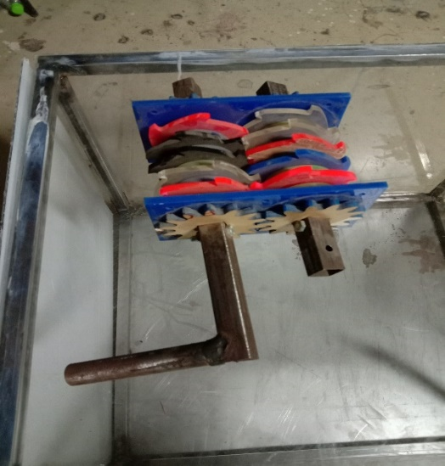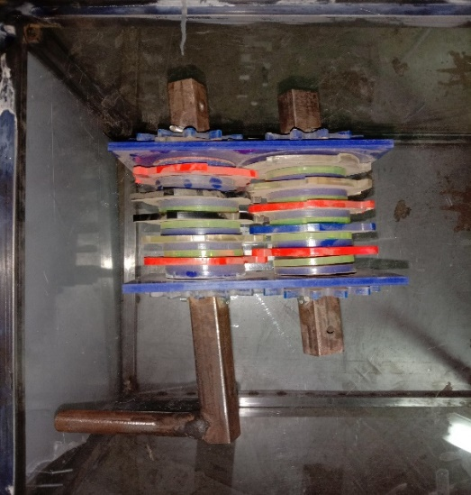
Fig.4.1 Existing shredding mechanism
2. Problems occurred in operation
- The assembly required more energy to operate.
- Distance between two blades or clearance was too less, it caused blockages.
- It’s required more time to convey and cut the material.
3. Conclusion:
From the above trial it concluded that the mechanism can’t work properly due to less clearance between blades, also due to the less bulk density of brown material.
For calculating or find out required clearance took some sizes of leaves which is as follows,
Table No. 4.2: Random Maximum -minimum size and thickness of dry leaves
Sr. No. | Length(cm) | Width(cm) | Thickness(mm)
1 | 14 | 2 | 1
2 | 11 | 6 | 1
3 | 8 | 5.5 | 1
4 | 8 | 4 | 0.5
5 | 11 | 2 | 0.5
6 | 16 | 2 | 0.5
7 | 7.5 | 5 | 1
8 | 7 | 5 | 0.5

- Maximum length of dry leaves =16cm
- Maximum width =5.5 cm
- Maximum thickness =1mm
4. Bulk density of dry leaves:
Bulk density of dry leaf waste was necessary to find out for deciding the dimensions of hopper. First the dry leafs was taken in tray. The weight and dimensions of tray was taken. Then weight of dry matter was taken. The waste was taken in tray as there is no too much space between particles. The care taken was the waste does not overflow from tray. The weight of waste was taken and recorded.
Dimensions of tray were 36 x 25 x 7 cm.
Volume of tray = 36 x 25 x 7
= 6300 cm³

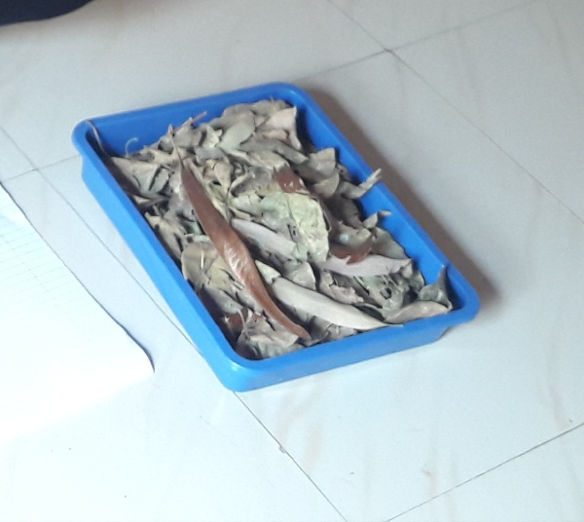
Fig. no. 4.2 different sizes of leaves
- Weight of tray = 300 gm
- Volume of tray = length ×width× height
= 36×25×7
=${6300 cm}^{3}$ = 0.006300 $m^{3}$
- Mass of dry leaves =0.288 kg

- Bulk density of dry mass = $\frac{mass }{volume}$
=$\frac{0.288}{0.06300}$
= 45.714 kg/$m^{3}$
Trial 2
Objective: The 2nd trial was carried out on same mechanism with decreasing size of assembly and increase the clearance between blades, Assembly consist of,
Table No. 4.3 2nd test carried on given mechanism
Sr. no. | Particulars | No. | size
1 | Shaft | 2 nos. | 25 mm dia.
2 | Blade | 7 nos. | 10 mm thickness
3 | Gear | 2 nos. | 10 mm thickness
4 | Clearance between two blades |  | 8mm
5 | Weight of dry material | 100 gm
6 | Time require to convey material through mechanism | 3min.40sec.
7 | Speed | 14 rpm
8 | Material used for prototyping | Acrylic sheet | 10mm thick

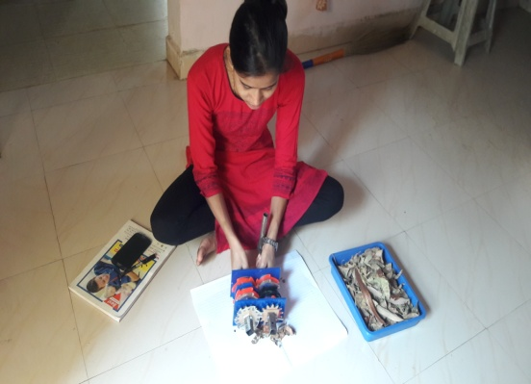 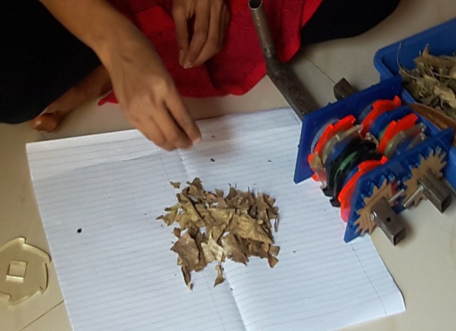 Fig.4.3 shredding assembly Fig.4.4 shredded material

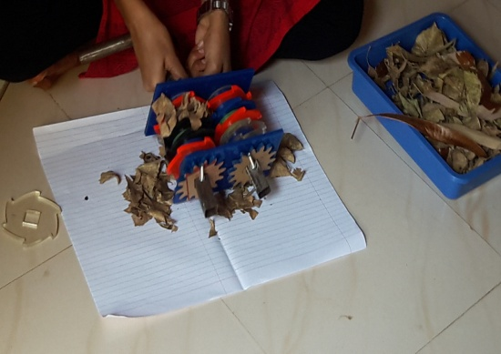
Fig. 4.4 working assembly
Conclusion: from this trial we concluded that the assembly required more energy to operate but reduce time as compare to 1st one.
In this mechanism dry material convey easier than existing mechanism. Due to increase the clearance between the conveying blades.
Then we decided that, designed new and different type of blades which convey the material in large amount than the shredding and also increase the clearance between the blades and took trial on it.
Trial 3
Objective: design and development of conveyor cum cutting shredder mechanism (prototyping).
Material: acrylic sheet pencil, scale, cutting tools etc.
To found out the conveying mechanism for pulverizer, we design another prototype mechanism and test it.
Procedure:
- Firstly, collect the information about different blades which was used for shredding and also for conveying.

- drawing of different types of blades :
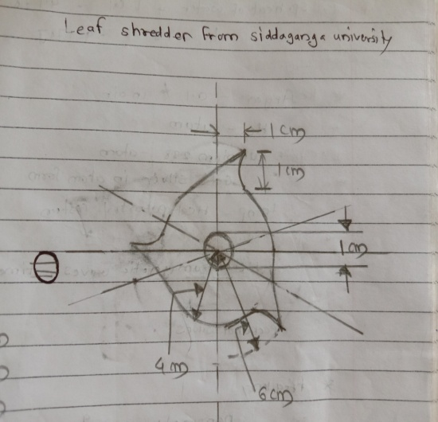

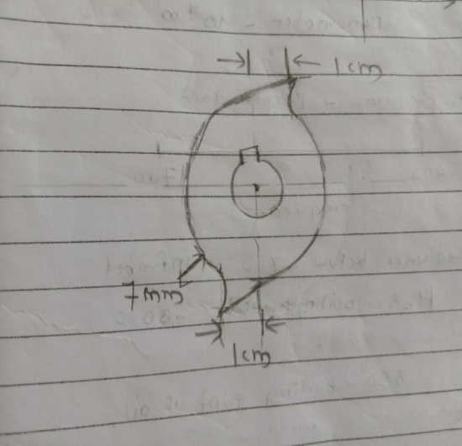 Fig.4.5 three toothed conveying blade Fig.4.5 two toothed conveying blade
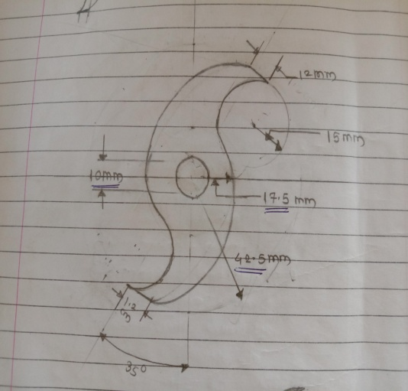 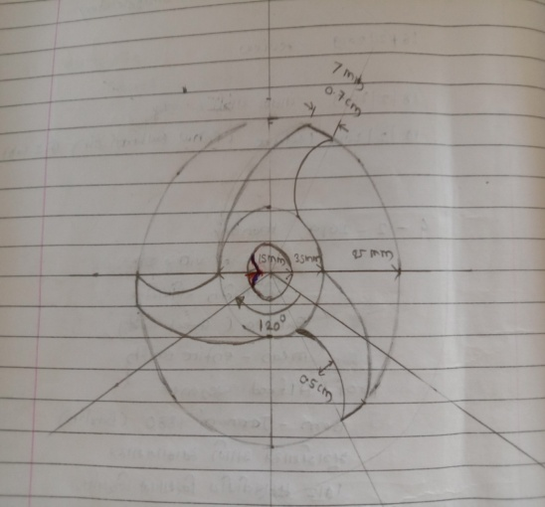 Fig.4.6 two toothed cutting blade Fig.4.7 three toothed cutting blade

- Selecting two types of blades for mechanism from their properties.

- Then Finalized the dimensions of blade for given mechanism.

- Designed two different type of blades. Two and tree toothed blade was selected.

- Blade 1st consist of dimensions of 85mm dia. And thickness of 3mm with 2 toothed blades
The selected designs were designed in solid works,
- Blade 1: Two toothed shredding cum conveying blade.
- Extruded blade design
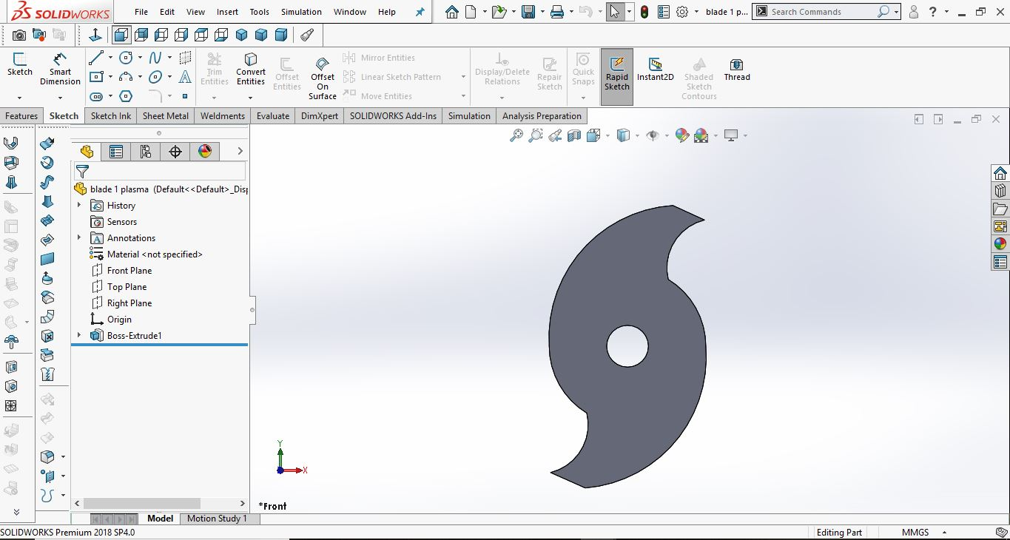
Fig.4.9

- Blade 2: three toothed shredding cum conveying blade.

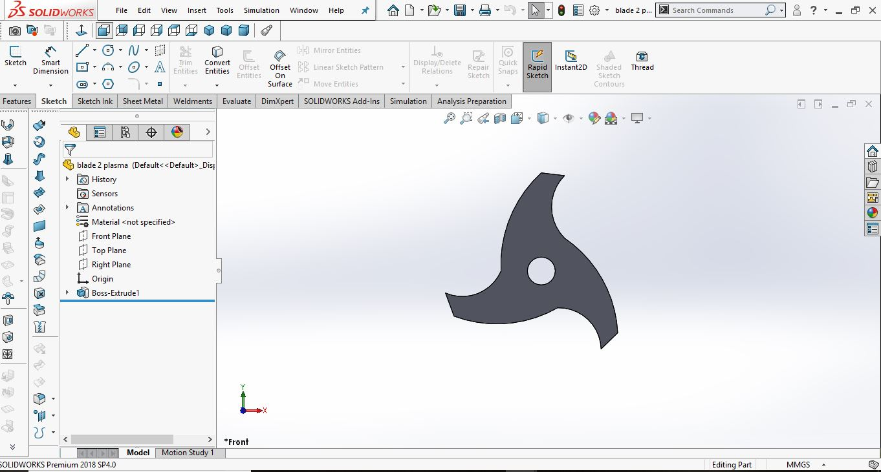
Fig.4.10

- Clearance plate: This is used to keep particular distance between two blades.

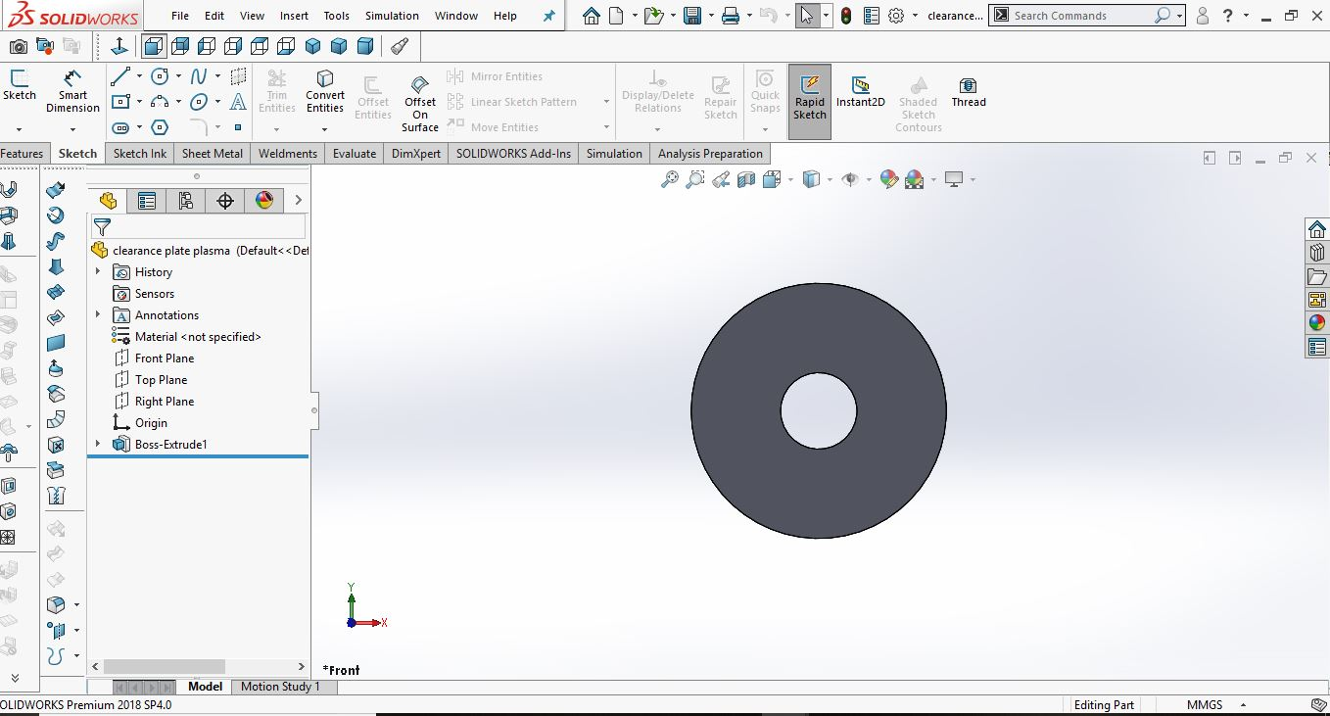
Fig.4.11

- Gear: the gear which is designed in solid work for transfer the motion from one point to another.

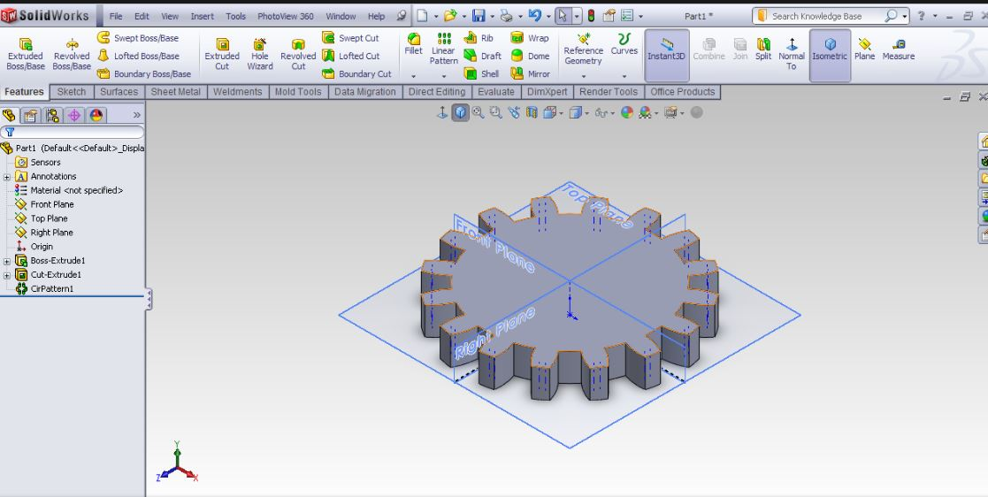
Fig.4.12

- after designed the all parts ,they cut on laser cutting machine,
Laser machine : This is applicable for home Appliance, Environmental Equipment, Petroleum Machinery Manufacturing, Agriculture Machinery, Textile Machinery, Food Machinery, Aerospace Industry, Automotive Industry, Shoemaking Industry, Woodwork Industry, and Advertising Industry.
Laser cutting is mainly a thermal process in which a focused laser beam is used to melt material in a localized area. The laser optics and CNC (computer numerical control) are used to direct the material or the laser beam generated. The focused laser beam is directed at the material, which then either melts, burns, vaporizes away, or is blown away by a jet of gas, leaving an edge with a high-quality surface finish. The CO2 laser which is capable of cutting, boring, and engraving, this is used to cut the typical edges if the shredder blade. The reason of Laser cutting done to this that, when the blade undergoes other machining processes, the material properties tend to change. This also results in the reduction of wear resistance. But when the blade is being cut by the Laser cutting method, the property of the material of blade remains unchanged

Table no.4.4
Cooling System: | Water Cooling
Technical class | Continuous Wave Laser
Applicable Material | Nonmetal
Structure Type: | Gantry Type

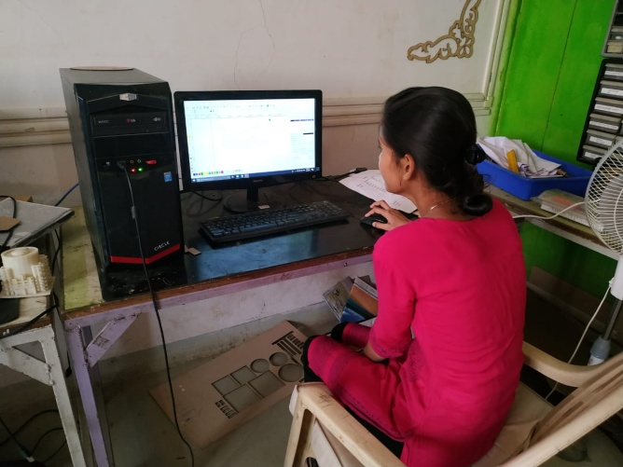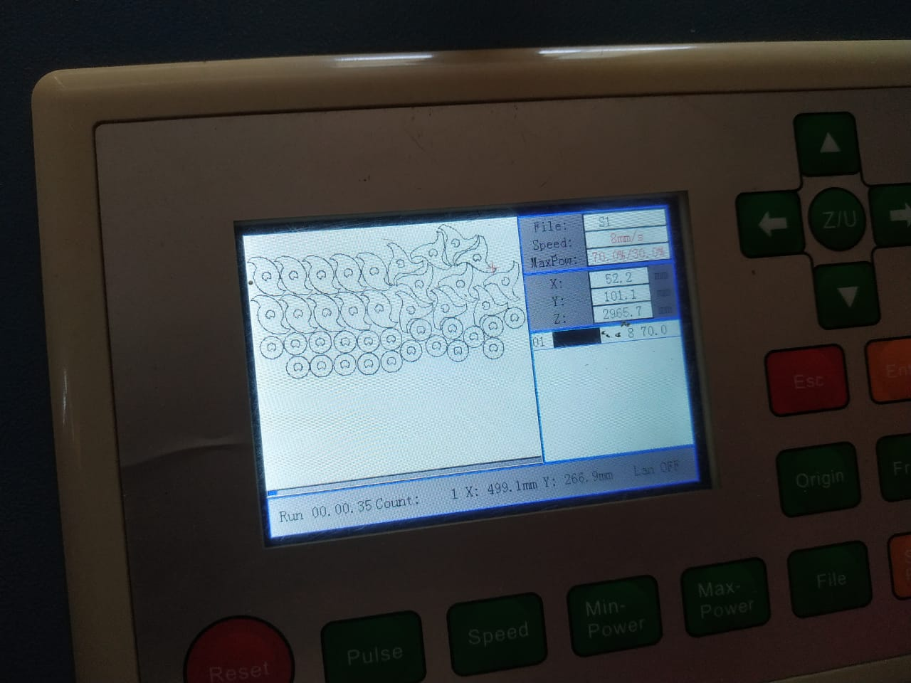
Fig.4.13 Fig.4.14 dxf files

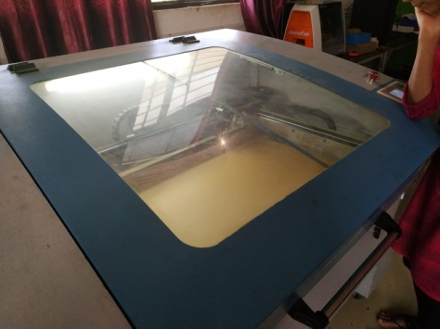
fig.4.15 laser cutting on acrylic sheet
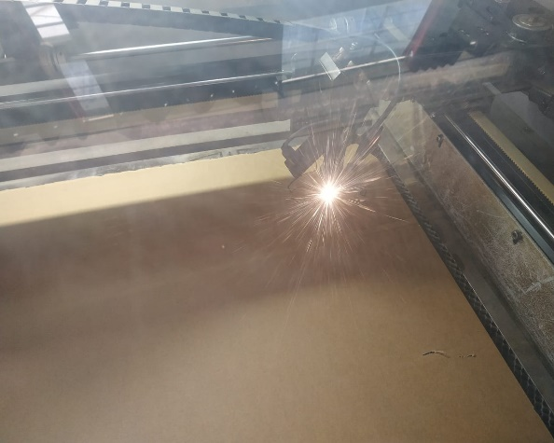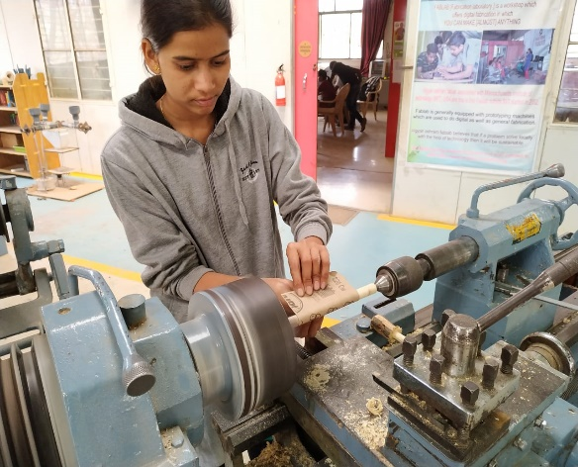
Fig.4.16 laser cutting Fig.4.17 wooden shaft turning on lathe
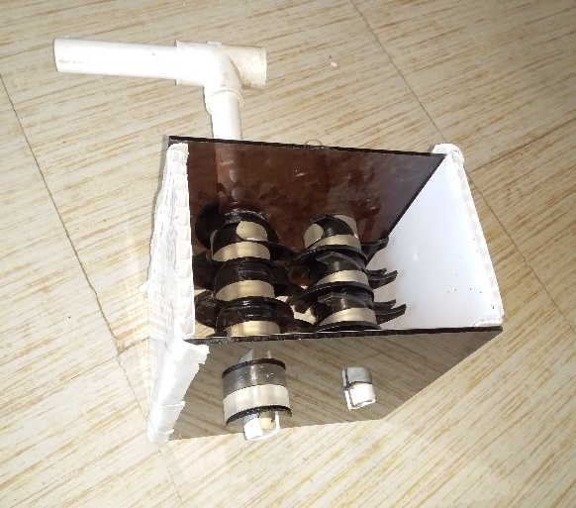  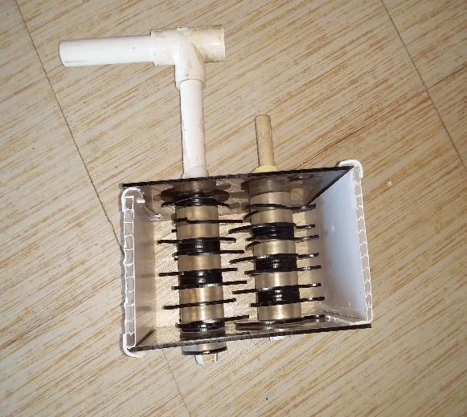  conveying mechanism  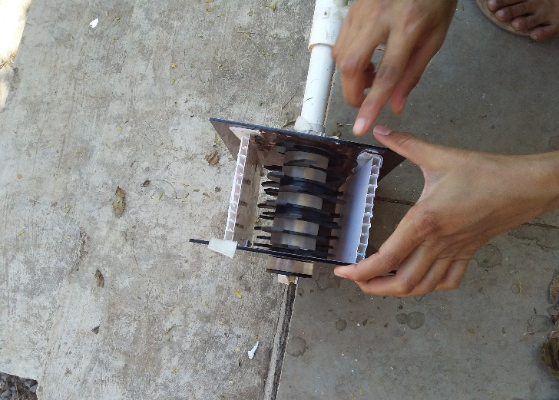  Fig.4.19 conveying prototype for dry leafs  Table no. 4.5 assembly consist of following parts ,  Sr. no. Particulars No. size  1 Shaft 2 nos. 15mm dia.  2 Blade 8 nos. 3 mm thickness  3 Gear 2 nos. 10 mm thickness  4 Clearance between two blades - 10mm and 8mm alternate  5 Weight of dry material 100gm -  6 Time require to convey material through mechanism 3min.40sec. -  7 Speed 14 rpm -  8 Material used for prototyping Acrylic sheet 10mm thick  9 Density of acrylic material 1.2sgm /cm³ |  |  | size
conclusion :
Trials was kept on two position on mechanism ,single shaft and double shaft mechanism .It concluded that the single shaft mechanism convey the more materail than the double shaft .double shaft was suitable for cutting purpose of different materail.
- Double shaft mechanism : To convey the 100 gram of dry mass ,required 3 min.15 sec.at the speed of 12 rpm.
- Single shaft mechanism : To convey the 100 gram of dry material from mechanism its required 1 min 15 sec. at the speed of 18 rpm.
This trial was successful and it was concluded that single shaft convey more than the double shaft mechanism ,therefore we used single shaft to convey the dry material into pulverizer.
System finalisation :
Functional Components of Developed pulverizer hopper:
The mechanism to be developed would be comprised of number of working components viz., supporting stand, hopper, blades shaft, chain and sprocket bush-bearing etc . These individual components could be explained in detail as below.
- Hopper
- Blades
- Shaft
- Bush-bearing
- Chain and Sprocket
- Supporting stand
- Motor
1. Hopper :
The main function of hopper is to store the dry material to be placed into the pulverizer for pulverizing. The pulverizer had a large hopper for storing the material and delivers it through conveying mechanism into pulverizer. The hopper was provided for easy placement of dry material for shredding. Another purpose is to reduce the time required to put material into pulverizer. The selection of the shape of hopper was done with the basic consideration that hopper should carry desired quantity of dry material and there bulk density. The hopper was situated at top of the conveying mechanism.
Hopper of the pulverizer was made of GI sheet. The design methods were adopted as given by Sharma and Mukesh (2010) for fertiliser boxes as follow
Volume of hopper is given by,
V_{b} = 1.1
Where,
V_{b} = Volume of box
W_{s} = Weight of briquettes, gm
Y_{s}= Bulk density of briquettes, gm/cm³.

Now,
For light weight and easy operation of the mechanism the capacity of the hopper was considered as 1 kg hopper. So, theoretical volume of hopper required,
=$\frac{1}{45.71}$
= 0.218 m³
^{= 21800 cm3}
size of the hopper ,32×32×31cm then the capacity of hopper was 1.03 kg.
^{for 2 kg of hopper,} V_{b} = 1.1
=2/45.71=0.0437 cm³ =43700 cm³
size of the hopper should be 383831 cm = 44764 and the capacity of hopper was 2.05kg
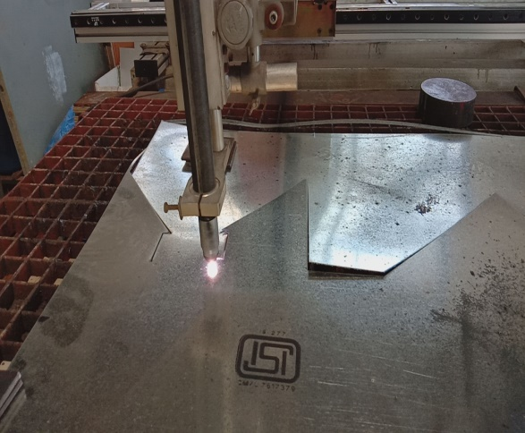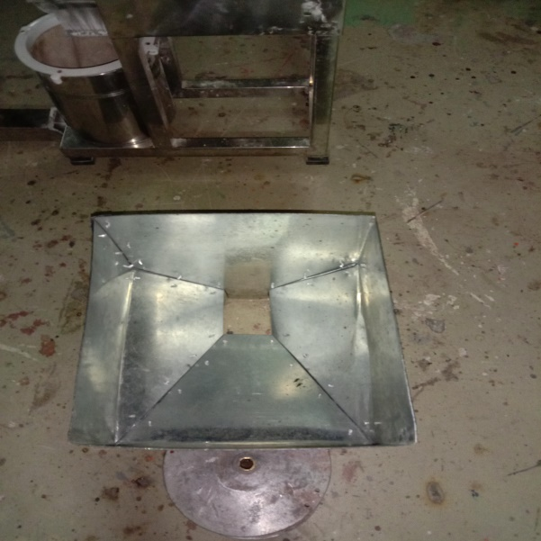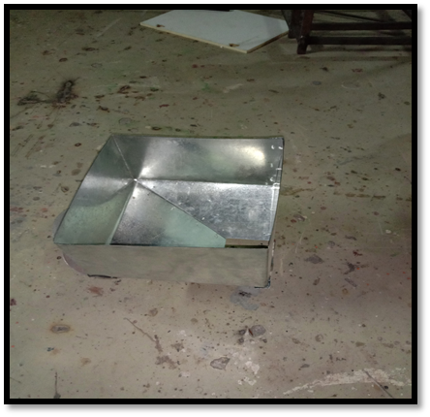
^{Fig. hopper}
^{Inclined hopper sheet:}
The inclined portion of assembly which was design in solidwork on the basis of pulverizer inlet source.which was aslo cut on the plasma cutter machine.
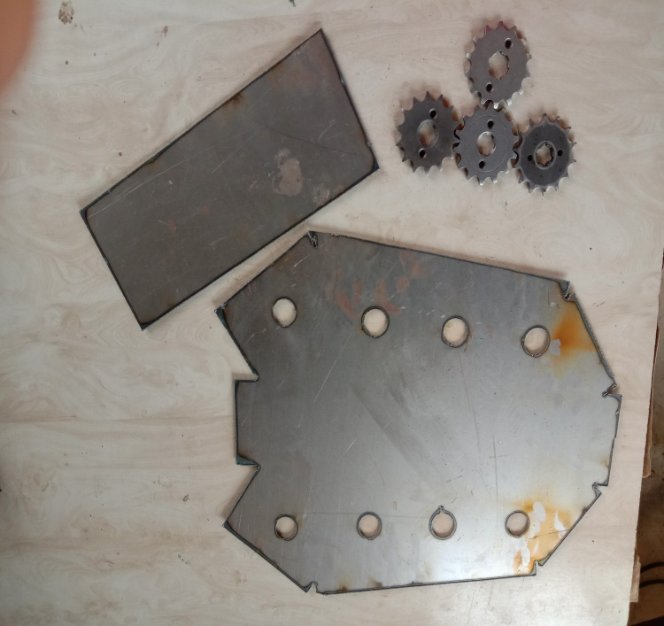
Fig. hopper sheet for mechanism
^{2.Blades :}
The shredder blade plays the major role in the dry matter shredder machine. There are many types of shredder blades and the one which is used is a three edged blade and tow edges blades. A space is also provided between each of the Blades for the shredded pieces to come down.
The blades which were made up of MS sheet of 0.8 mm size, the dimension of the blade was selected from the hopper inclined portion, to convey the material through mechanism the blades are made mild steel and of length of different dimensions, four types of blade all blade were fix to the shaft with the help of the fix nut.
^{specification of blades,}
^{Table no.4.6}
^{Sr. No.} | ^{Shaft} | ^{Two toothed blades Dia.} | ^{Three toothed blades Dia.}
¹ | ^{first shaft} | ^{110 mm} | ^{110mm}
² | ^{second shaft} | ^{92mm} | ^{92mm}
³ | ^{third shaft} | ^{82mm} | ^{82mm}
⁴ | ^{fourth shaft} | ^{72mm} | ^{72mm}
The blades were cut on the plasma cutting machine some of them are as follows,
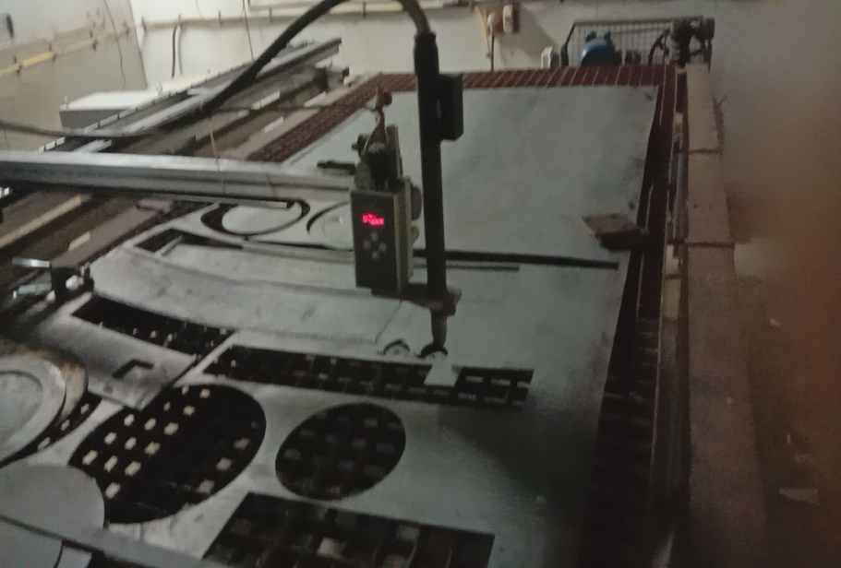
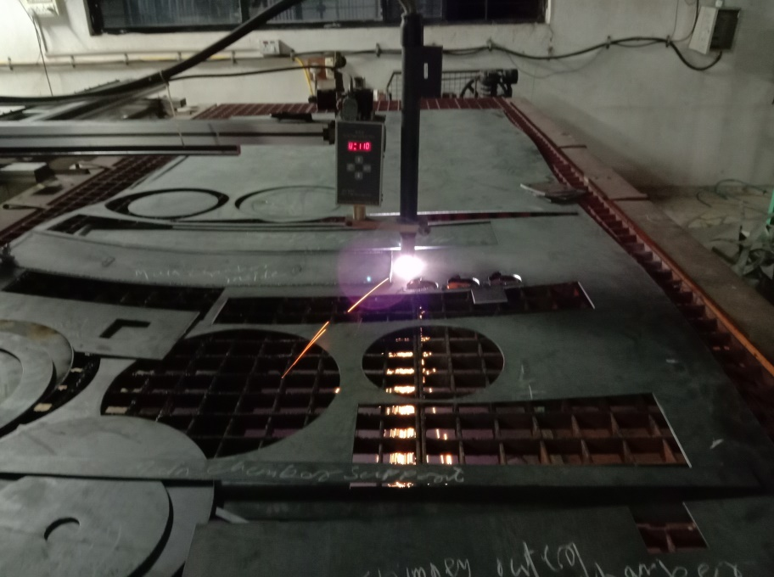
fig. blade cutting on plasma cutter machine
^{3.Shaft:}
In this chapter, the general design considerations related to to the plastic shredding machine are discussed. This chapter highlights on general design considerations and procedure of main components and accessory components of developed conveying mechanism of pulverizer. The conveying of material is done by different conveying systems.screw conveyor belts etc which was used to convey the material.
Main Shaft
A shaft is a rotating machine element which is used to transmit power from one place to another. The power is delivered to the shaft by some tangential force and the resultant torque (or twisting moment) set up within the shaft permits the power to be transferred to various machines linked up to the shaft. The shafts are classified as follows,
Transmission shaft
These shafts transmit power between the source and the machines absorbing power. The counter shafts, line shafts, overhead shafts and all factory shafts are transmission shafts. Since these shafts carry machine parts such as pulleys, gears chain and sprocket etc,
A 12 mm outer edge diameter high strenght shaft was selected for the mechanism,they were cut into the three same length and single one was took extra large for large sprocket mounting .
Calculations,
width of mechanism =150mm
maximum blade size :110mm
area of blade =2ԥr.h
=2×ԥ×55×0.8 =2.76 cm³
Volume of MS material = Area×Density
Density of MS material = 7.85 gm/cm^{3`}
= 2.76×7.85
=21.66 gm of material in single blade.
The mechanism consist of four shaft ,and each shaft mounted with 3 and 2 blades alternatly.
Area of shaft = 2ԥ×r×h
= 2×0.6×150
=3.76 cm²
Volume of shaft material = area × density of material
= 3.76×7.85
=29.51 cm³

4.Bush and bearings :
The 6201 deep grooved ball bearing were used for the mechanism.deep grooved ball bearing are used to transmit loads from rotating parts to housing with minimum friction loss.this will be obtained by a high hardness.minimize the deformation of the bearing elements. Single row deep groove ball bearing are the most widely used roller bearing type in the world due to their versatility and overall performance.
The bush were made by the polypropelene material to fix the bearing into it.the polypropylene is a tough and rigid crystalline thermoplastic prodused from propene or propylene monomer. It is a linear hydrocarbon resin.
The chemical formula of polypropylene is C₃H_{6.}
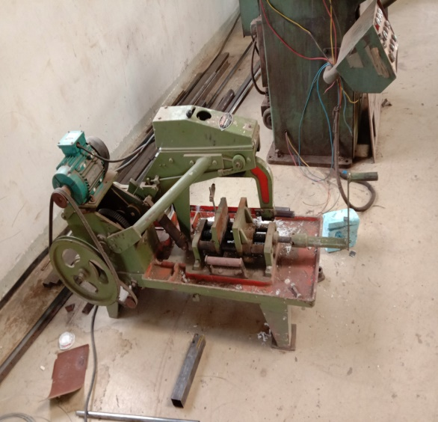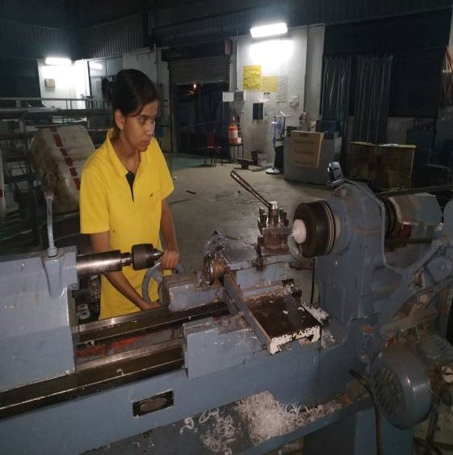
Fig .power cutter machine Fig. boring operation on pp
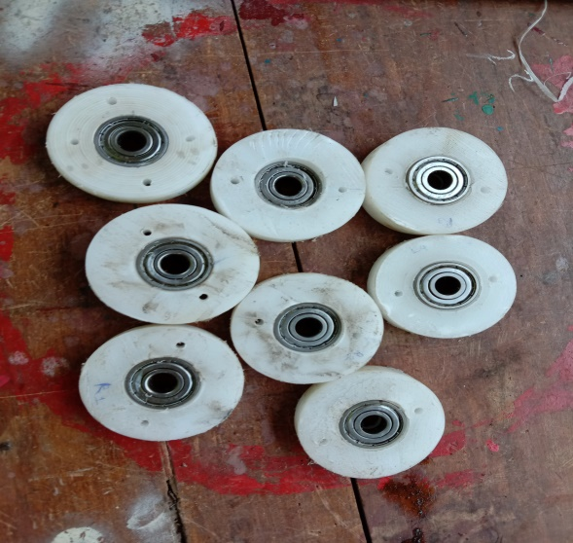
Fig bush -bearings
5.Chaine and sprocket :
Chain drives ,gear drives and belt drive system are all effective power transmission systems each offer advantages and disadvantages with respect to each other,
Chain drive are relatively easy to installed assembly tolerance are not as restrictive as those for gear drive .chain performance better than the gear under shock loading conditions.chian drive do not required tension on the sack side.chain drive required less space for agiven loading and speed condition than the pulley and belt. It is less costly to build and maintain.
For the conveying mechanism we used the 1.2 m chain ,5 small sprockets and one large sprocket to transmit the power from motor to the mechanism.
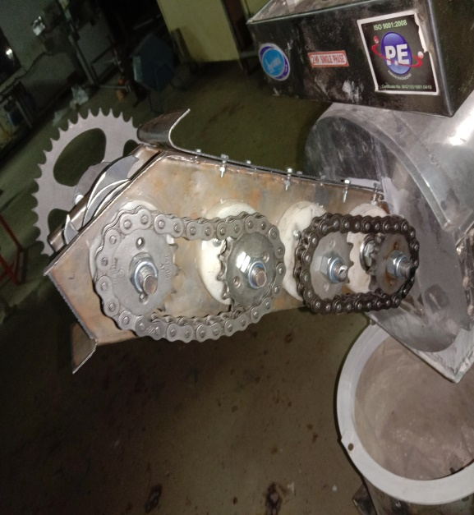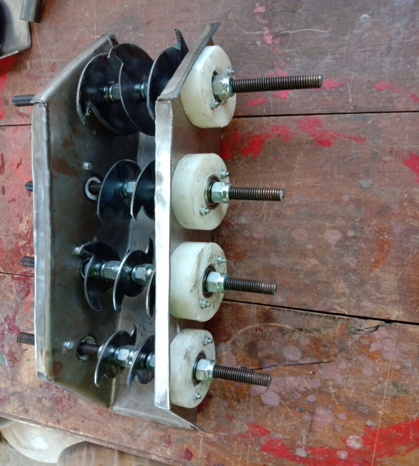
Fig. conveying assembly
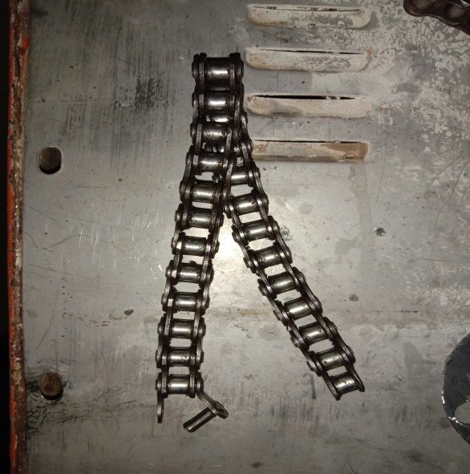
Fig. chain
Design calculations:
Feedrate of actual pulverizer machine was 500 gm/min.
Therefore material convey per second = 8.3 gm/sec.
Now,
The volume of hopper empty space = length × width × height
= 36.5×8.7×4
= 0.12702 m³
Tray volume = 45.71 kg/cm³
=0.045714 m³
Mass = density × volume
= 0.045714×1270.2
= 58.06 gram material present in the empty space of the hopper
The material contact with single blade
= 58.06/4 = 14.5 g/sesc.
500 gram was the feedrate of pulverizer then,material pulverize per sec.
= 500/60 =8.33 g/s.
Rpm required to convey the materail of 8.3 gram was ,34.3rpm =35 rpm
Force:
Force = mass × acceleration
Force required to convey the material on single blade ,
Material =14.5 Gram
Required force =0.0145 kg
=0.0145×9.81 acceleration due to gravity.
= 0.1421 N
Torque required (T) :
= force × radius (Fr)
= 0.1421×0.0425 = 0.006040 N-M
6. supporting stand :
The which made to gave support to the mechanism becouse of its heavy weight, with 73cm height and 10cm width. The L-angle were used for the shand.
7. Motor :
Motor used to drive the mechanism was AC synchronous motor of capacity of 3 kg-cm torque. Single phaase motor with the voltage of 240 V and the dimension of the motor should be 86×86×68 mm.

Bill of materail :
Sr.No. | particulars | quantity | cost
1 | Shaft
2 | blades
3 | MS sheet
4 | GI sheet
5 | Chain and sprocket
6 | bearings
7 | Fix nut
8 | PP roller for bush
9 | Nut and bolts
10 | Motor
11 | others

Result and conclusion :

 |  | 2 nos. | 25 mm dia.

